**Instagram Performance Report**

**(Power BI)**

# **Data Preparation & Cleaning (Power Query Editor)**

Tool: This analysis was performed using Microsoft Power Bi, the dataset was cleaned and transform to ensure the accuracy and usability of the dashboard using Power Query Editor then created multiple dashboards based on each sheet in the Instagram dataset for better understanding for each aspect.

1. Renamed the column like Date to Post date
2. Removed unnecessary or Empty Columns like RowHash.
3. Checked and Changed data types of columns if needed.
4. Standardized Text Fields
5. Added Custom Columns for better analysis
   1. Weekday Name: Extracted from Date to analyse trends by day
   2. Hashtags: Parsed hashtags from media caption column using power query
   3. Number of Hashtags: Calculated hashtags per post

# Data Analysis

## Dashboard 1: Instagram Overview

This dashboard is created to understand the profile performance over time

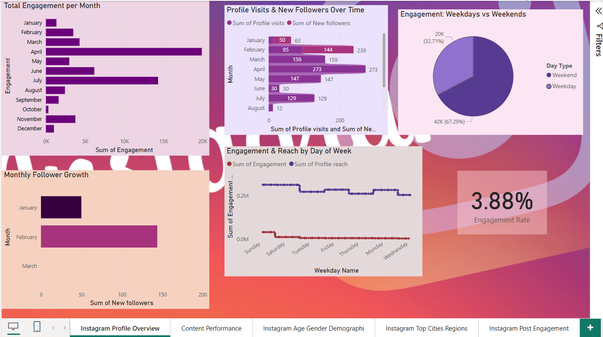

**Key Metrics and Measures:**

* Engagement Rate = DIVIDE( SUM([Engagement]), SUM([Profile reach]))
* Total Engagement = SUM([Engagement])
* Total Reach(Unique Users saw the post) = SUM([Profile reach])
* Reach to Engagement Gap = SUM([Profile reach]) - SUM([Engagement])
* Follower Growth = SUM([New followers])
* Day Type = IF(WEEKDAY([Post Date], 2) >= 6, "Weekend", "Weekday")
* Weekday Name = FORMAT([Post Date], "dddd")
* Average Daily Engagement = AVERAGE([Engagement])

**Visualization and Insights**

* **Total Engagement per Month**

This Bar graph shows Total Engagement of the profile per month and its pretty evident that April was the most engaged month and next comes July when engagement on the profile was good, least engaged month was October.

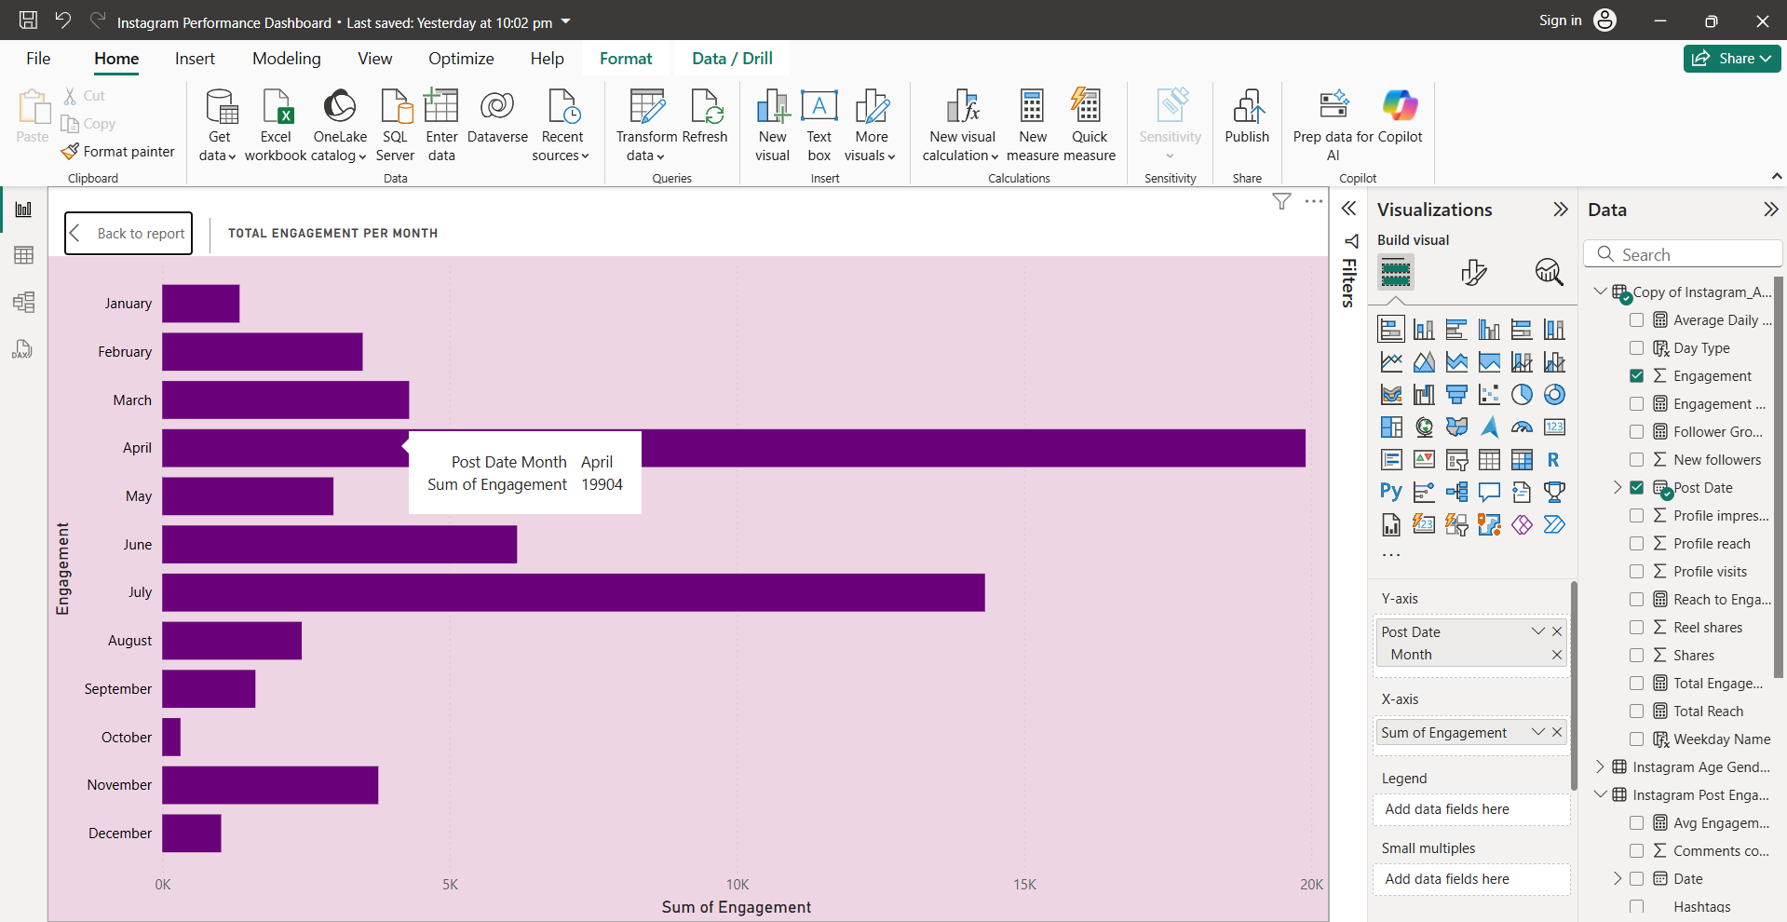

* **Monthly Follower Growth** Below bar chart Identifies when the brand gained the most followers, new followers were mostly gained in February 2025 where profile gained 144 new followers and secondly comes January 2025 with 50 new followers.

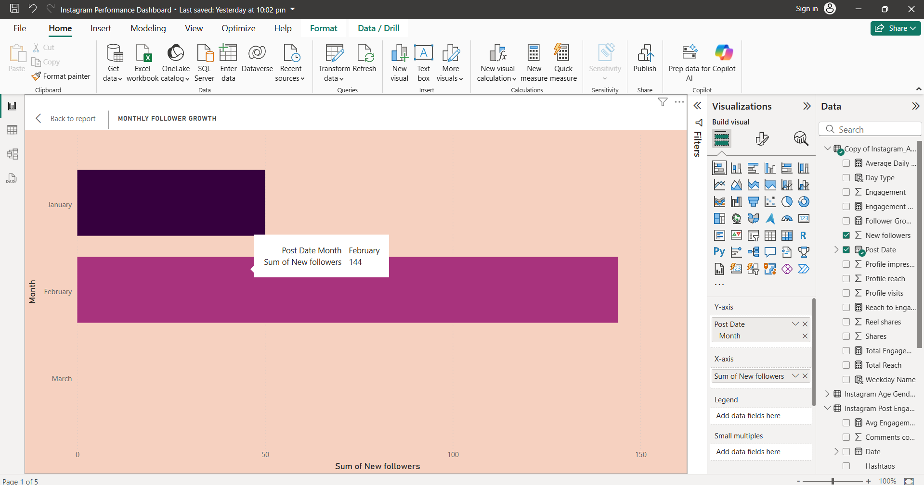

* **Engagement by Weekday vs Weekend**

Pie chart indicates engagement of the profile on weekdays and weekends, where Day type (Weekday or Weekend) was calculated from Post Date column (DD Month YYYY). Weekends often show higher engagement, which is an ideal for posting reels or posts.

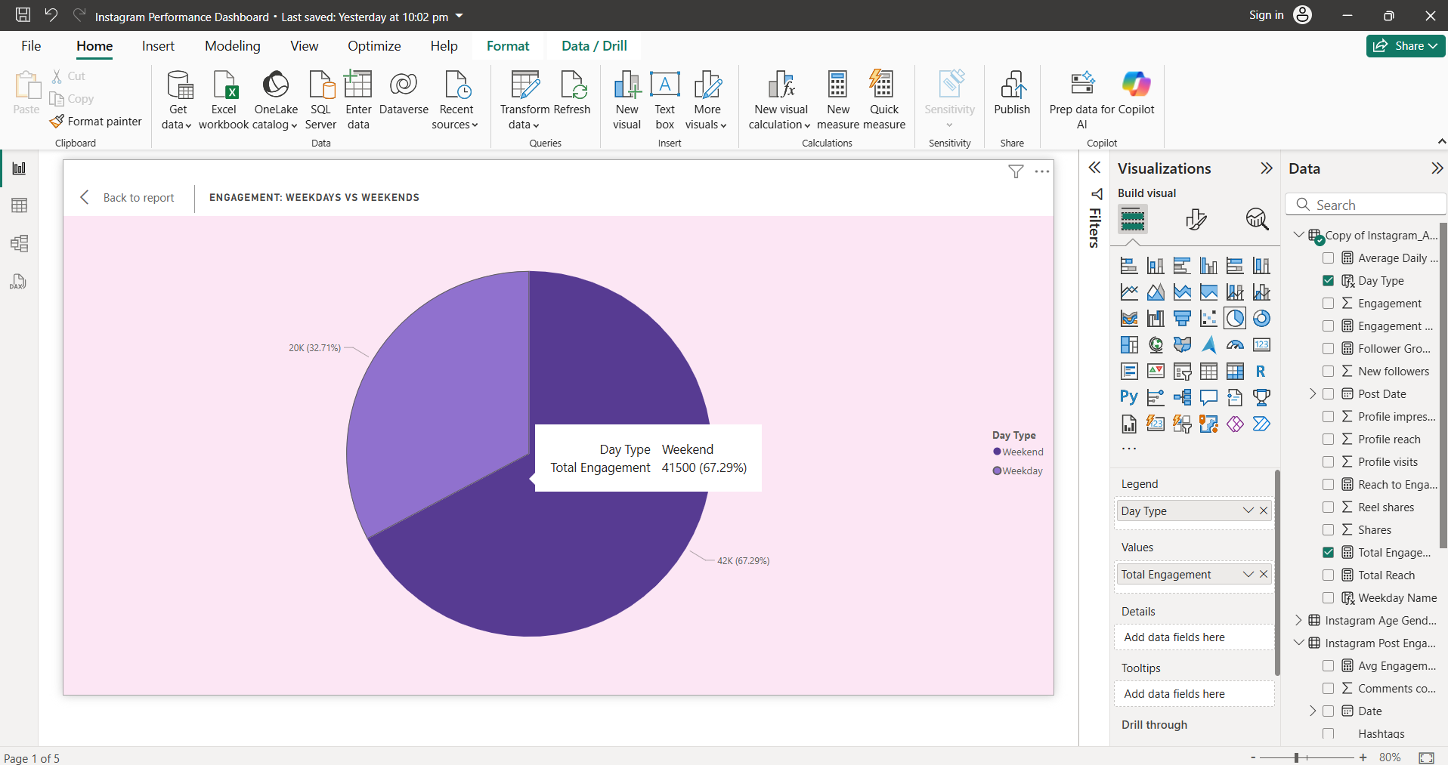

* **Profile Visits vs New Followers**

This Bar graph shows how many profile visits converted into new followers, Where Y axis display Months and X axis shows profile visits and new followers, two different colours

help to understand the exact numbers of new followers, As we seen before mostly new followers were gained in month of Feb.  
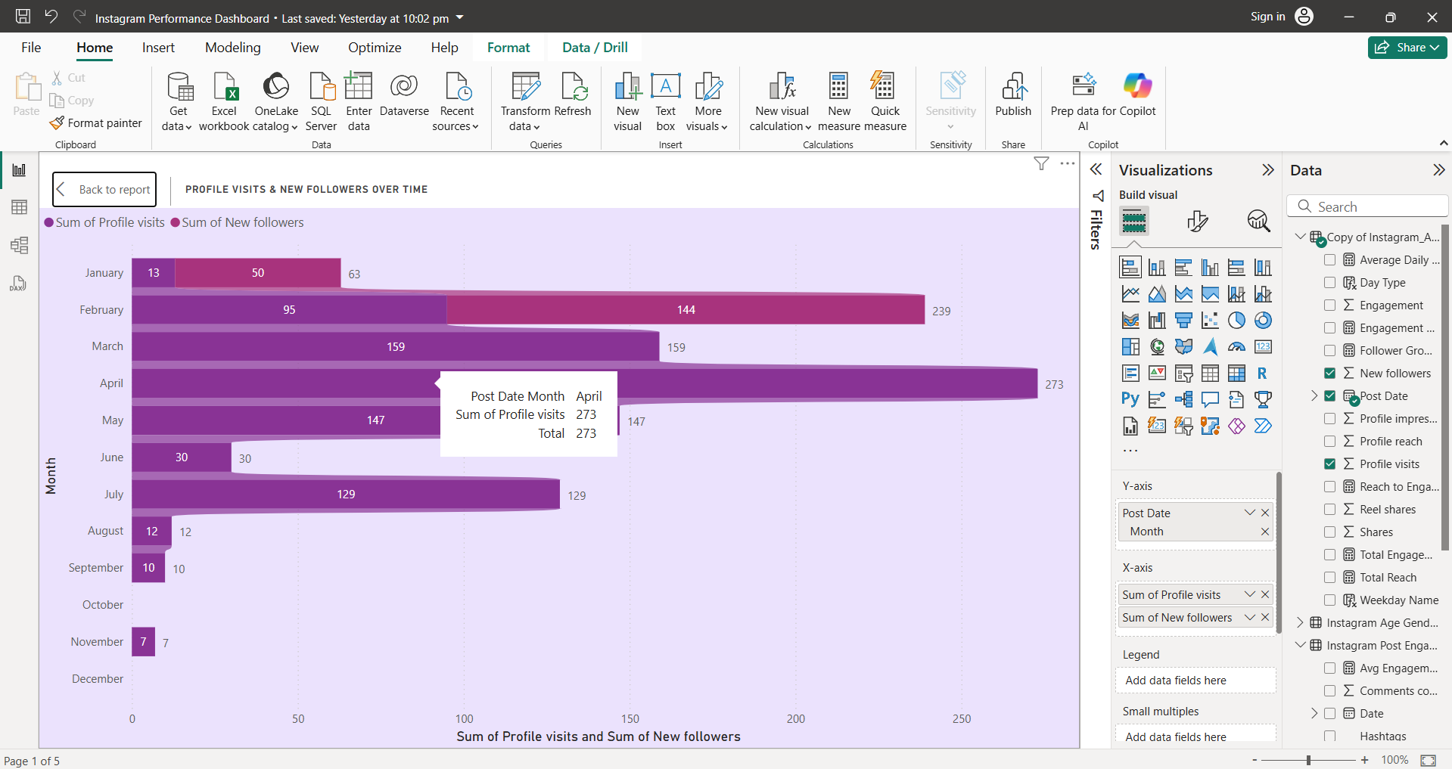

* **Engagement & Reach by Day**

It helps to schedule posts on high engagement or reach days. It is clear that Saturdays and Sundays are the most engaged days of the weeks.

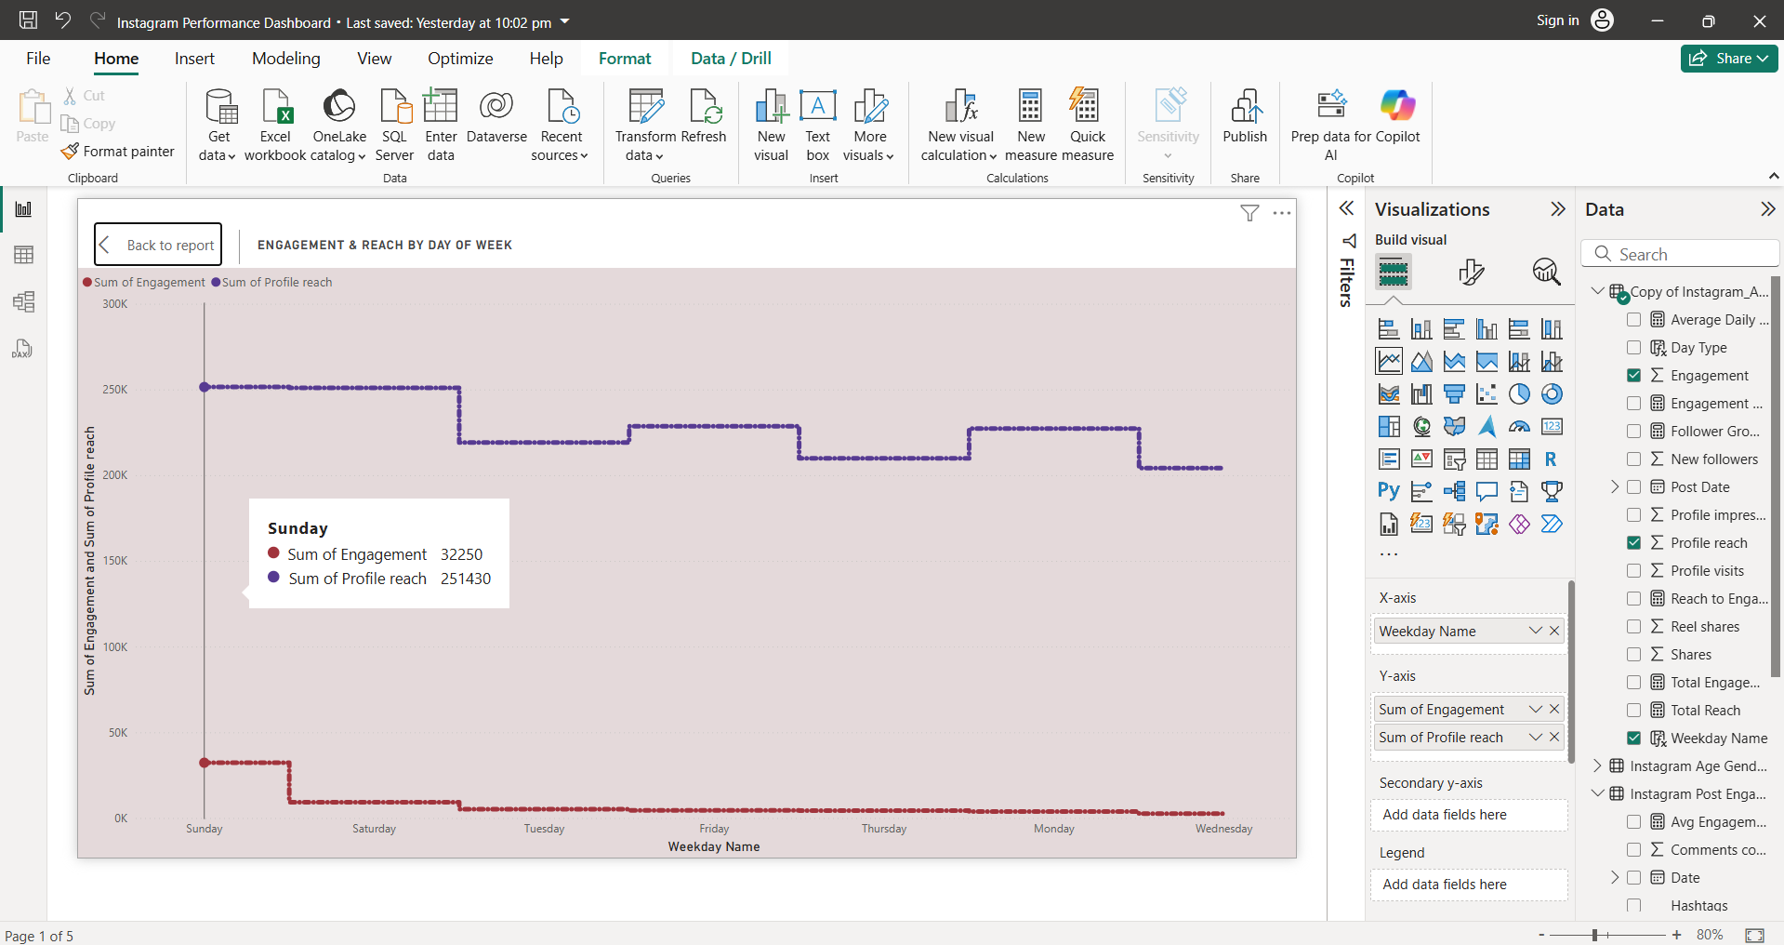

* **Engagement Rate**

A quick snapshot of performance effectiveness.

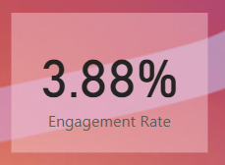

## Dashboard 2: Content Performance

This dashboard helps to understand how different types of content (Reels vs Feed) performs over time.

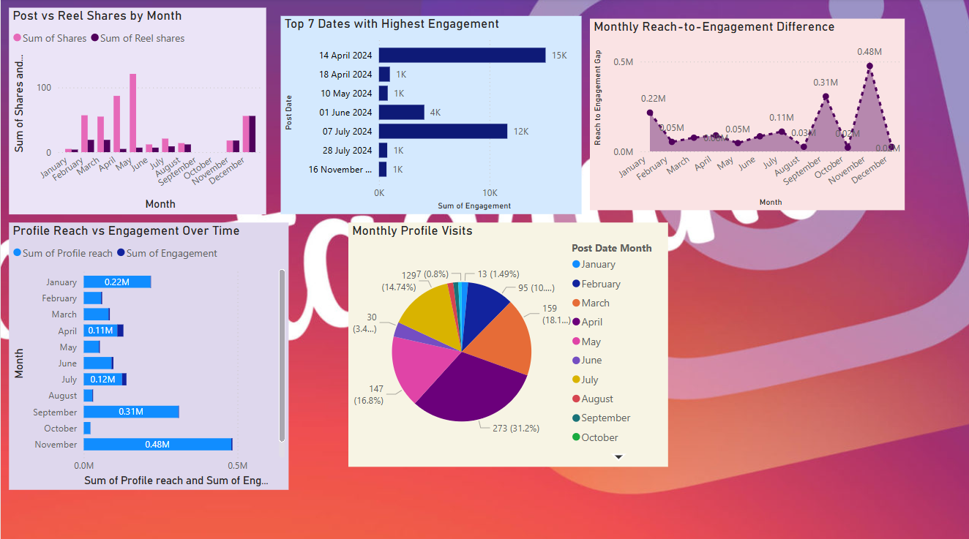

**Visualization and Insights**

* **Post vs Reel Shares by Month**

Here we are comparing Shares and reel shares over the time(monthly), and it’s evident that the greatest number of post shares happened in May and in December number of shares and reel shares were almost same.

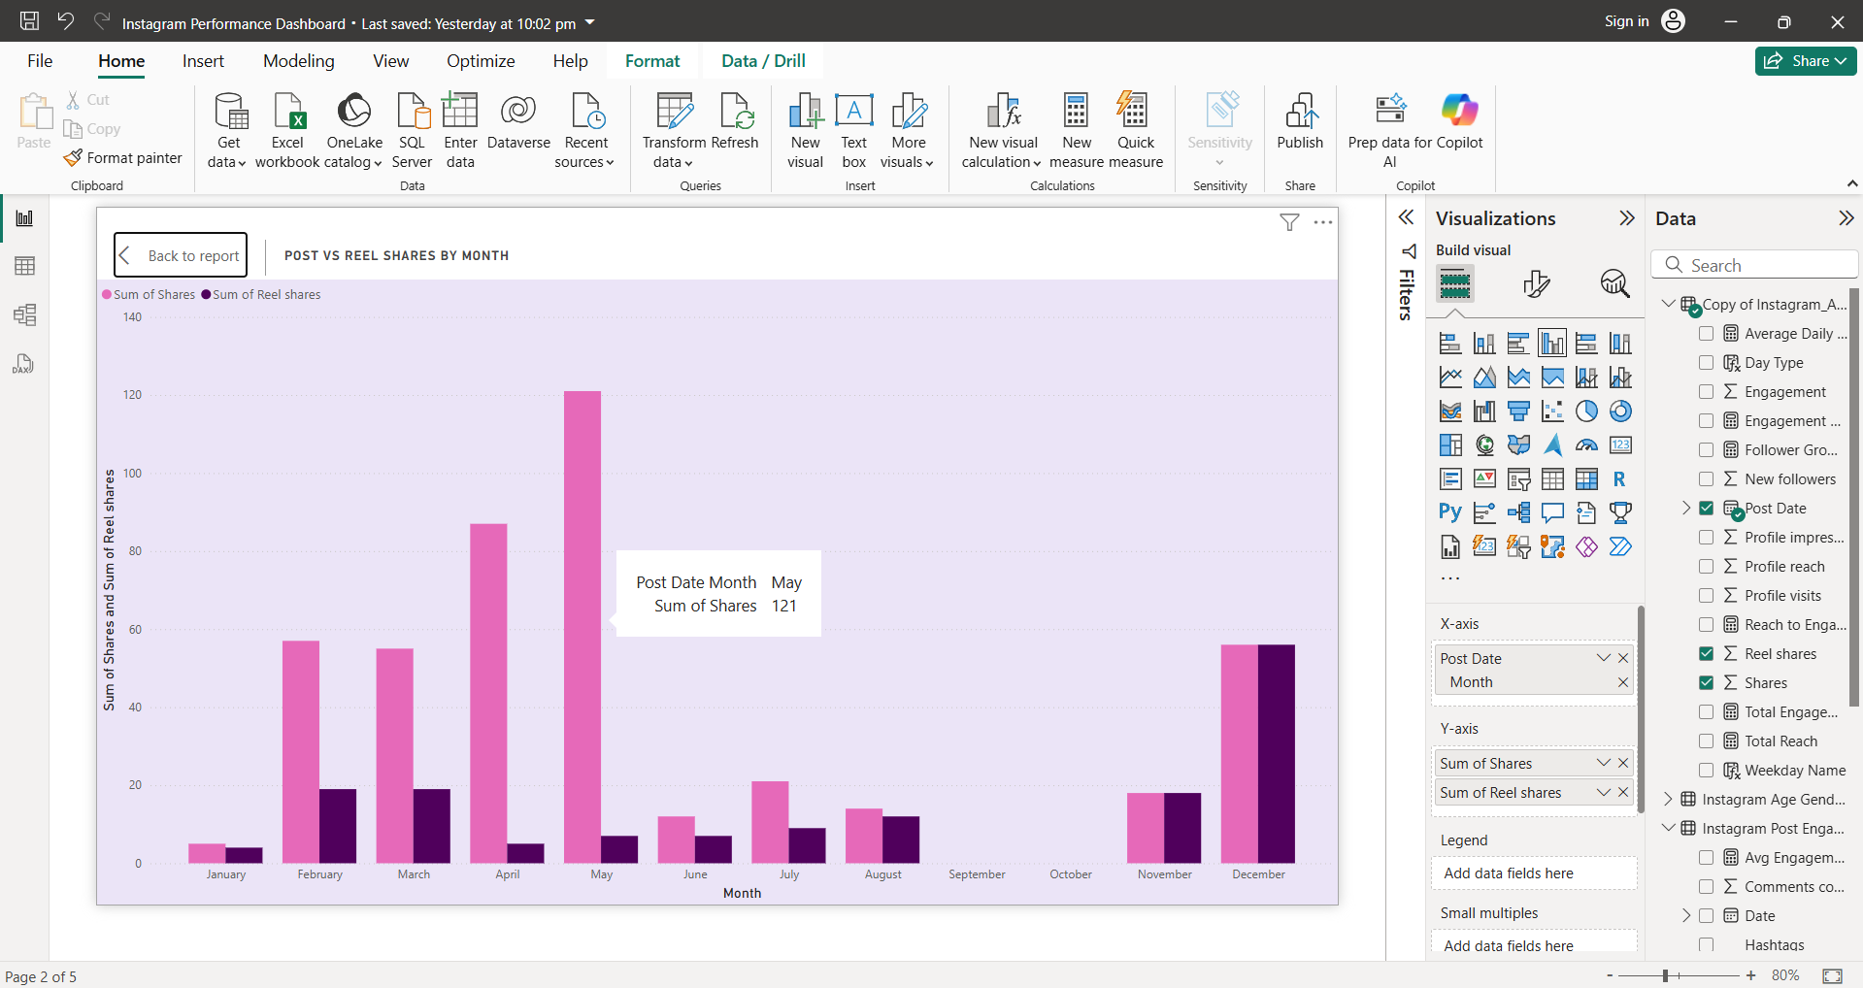

* **Profile Reach vs Engagement**

This bar chart shows Profile reach and engagement over time, showcase that High reach doesn’t always mean high engagement. Highest engagement is noted in April.  
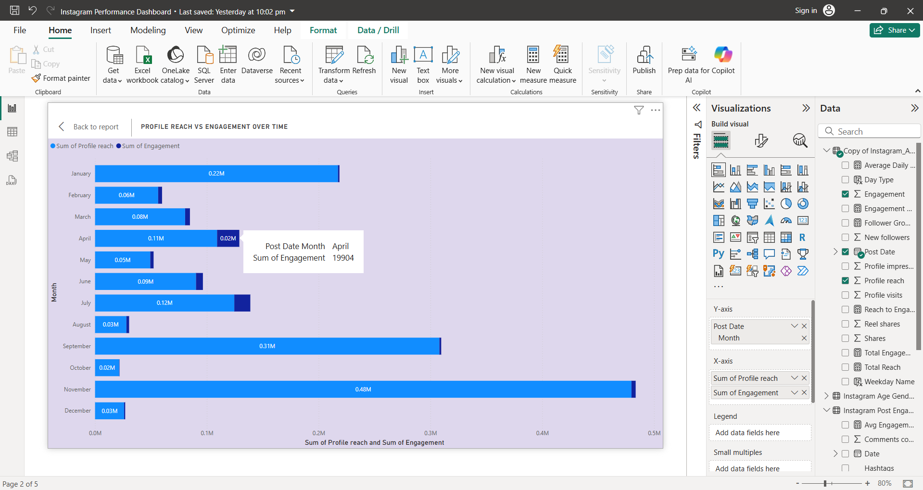

* **Reach to Engagement Gap**

In above bar chart we saw Profile Reach vs Engagement over time, this line chart will display the gap within them  
Meaning,

In April profile reach was 109151 and Engagement was 19904

So, Reach to Engagement Gap = SUM([Profile reach]) - SUM([Engagement])  
 Reach to Engagement Gap = 109151-19904= 89247, indicate passive viewers.

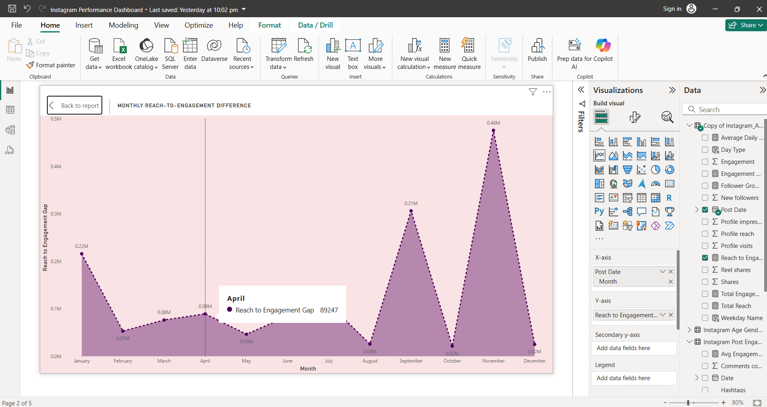

* **Top 7 Dates with Highest Engagement**

Below bar chart showcase the top 7 dates on which profile engagement was highest.

First comes 14 April 2024 with the highest engagement of 15k. Followed by 07 July 2024 with 12k engagement and 1 June 2024 with 4k.

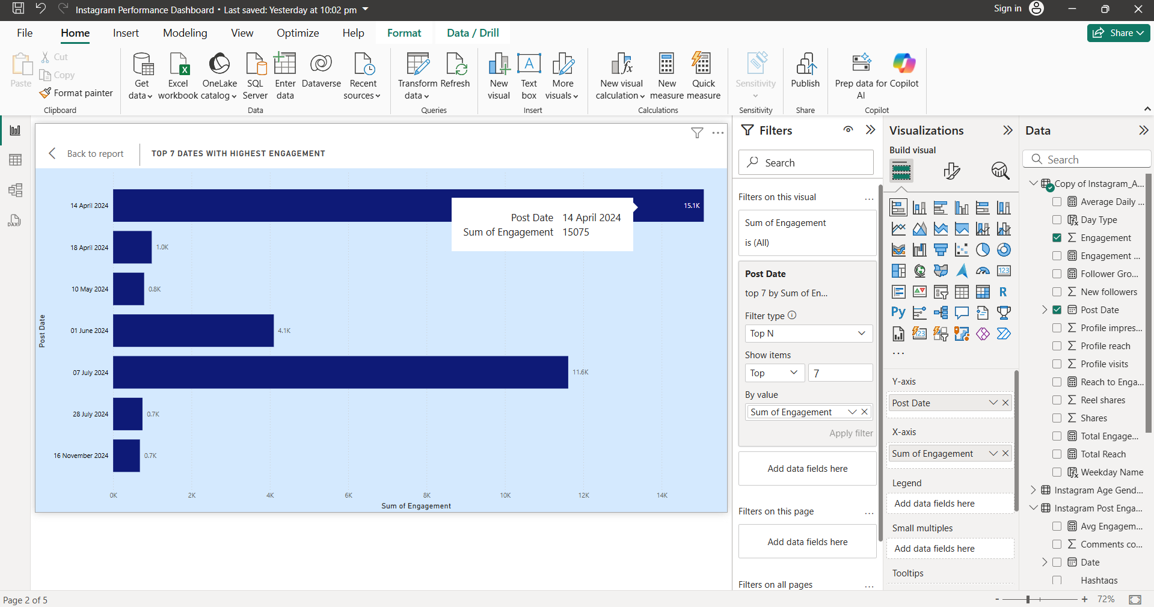

* **Monthly Profile Visits**

Pie chart is the best and easiest way to understand profile visits per month, as we saw earlier April has highest profile visits ( 273 that is 31.3%) and then comes March and May. Least were in November with just 7 profile visits.

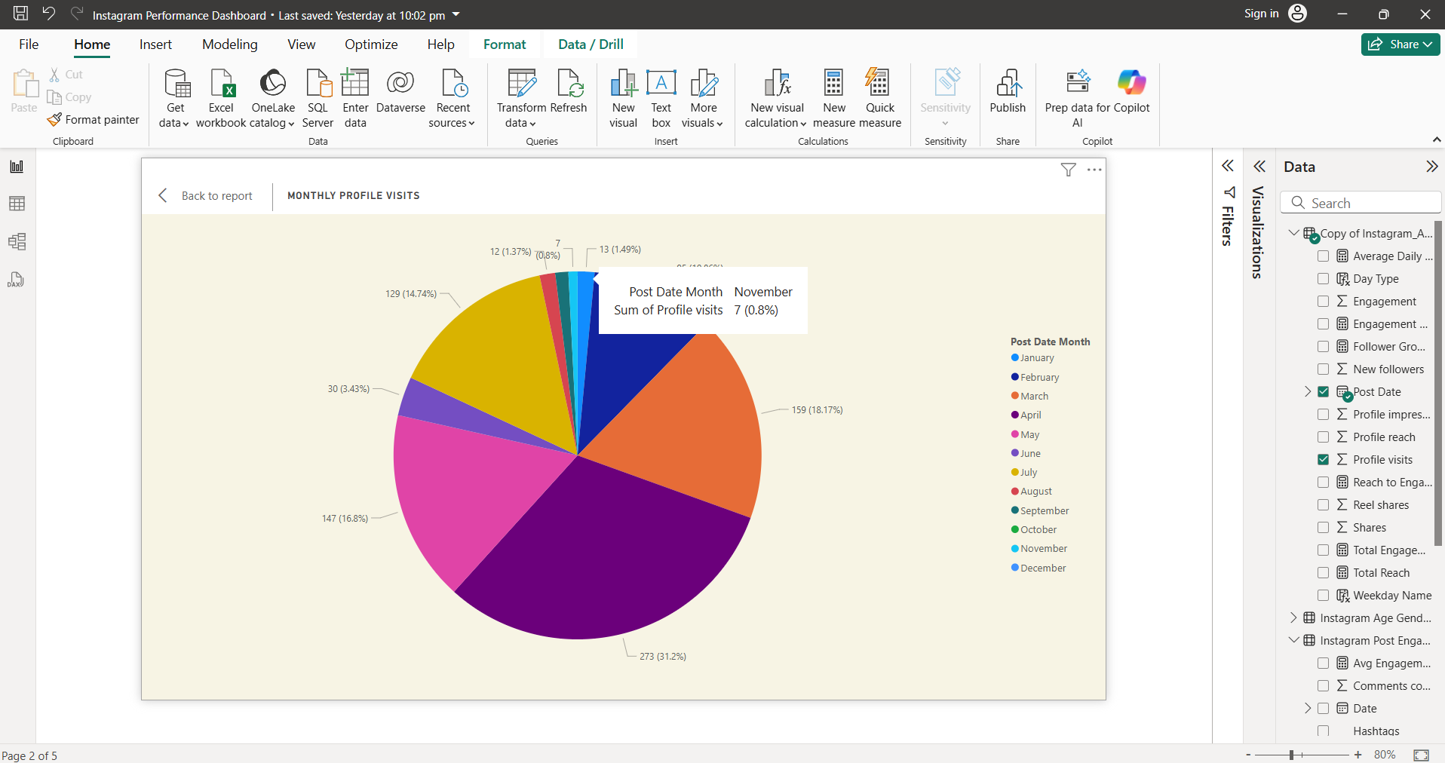

## Dashboard 3: Age & Gender Demographics

This dashboard displays follower segmentation.

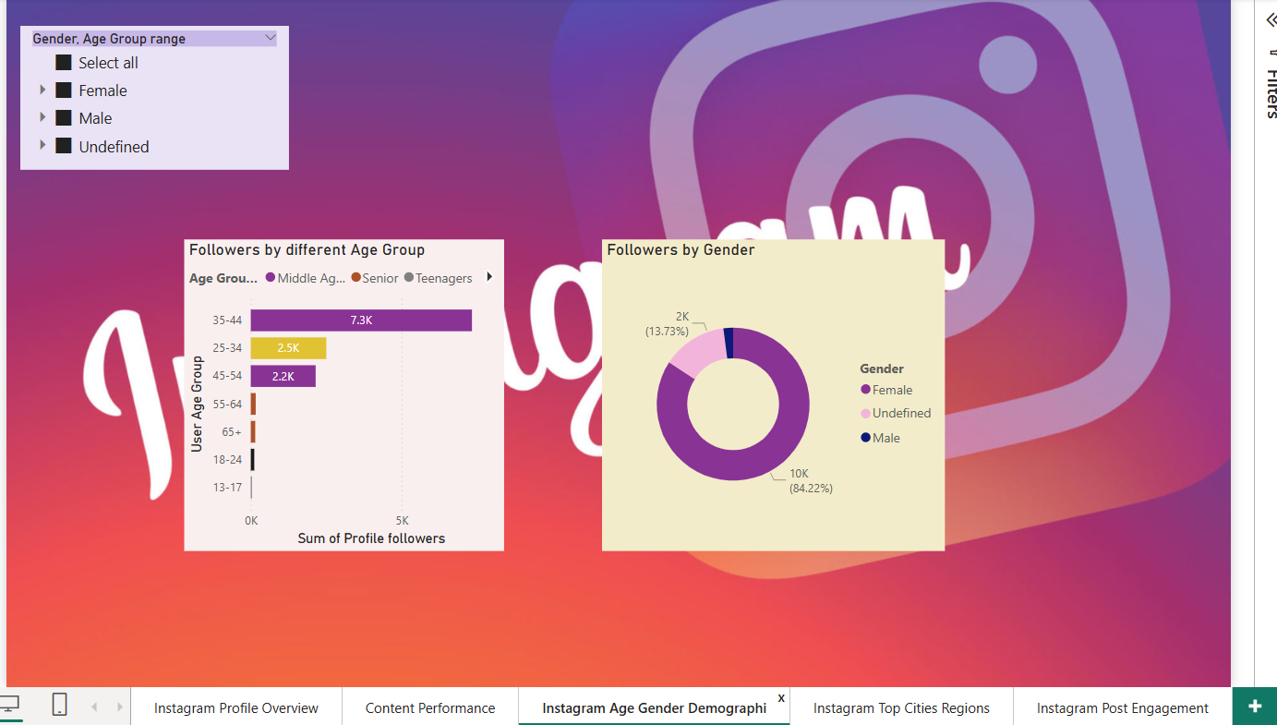

**Visualization and Insights**

* **Gender & Age Group Slicers**

Slicer helps to explore performance based on Gender and Age group, User can select particular Gender and Age group or can select all.

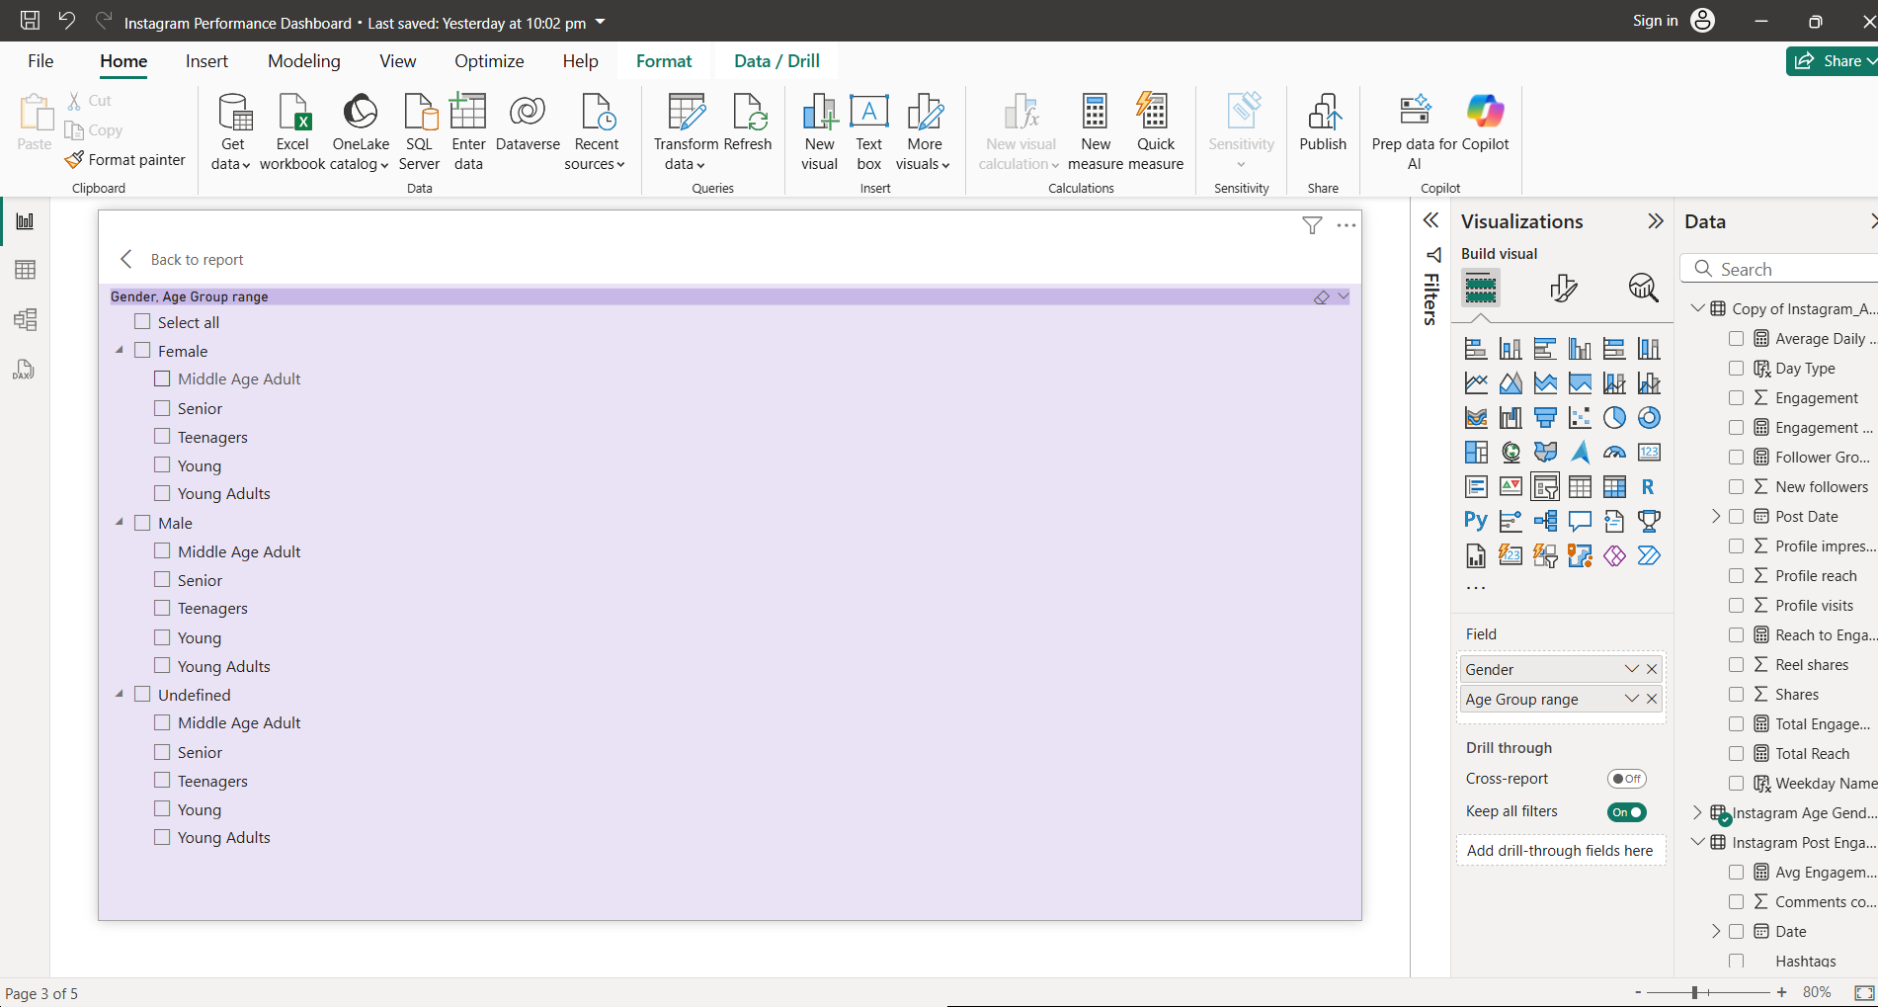

* **Followers by Age Group**

This bar chart indicates number of followers based on different Age group, It is visible that highest number of followers are from 35-44 that is 7.5k and the lowest one is 13-17(Teenagers) so content can be adult-focused.

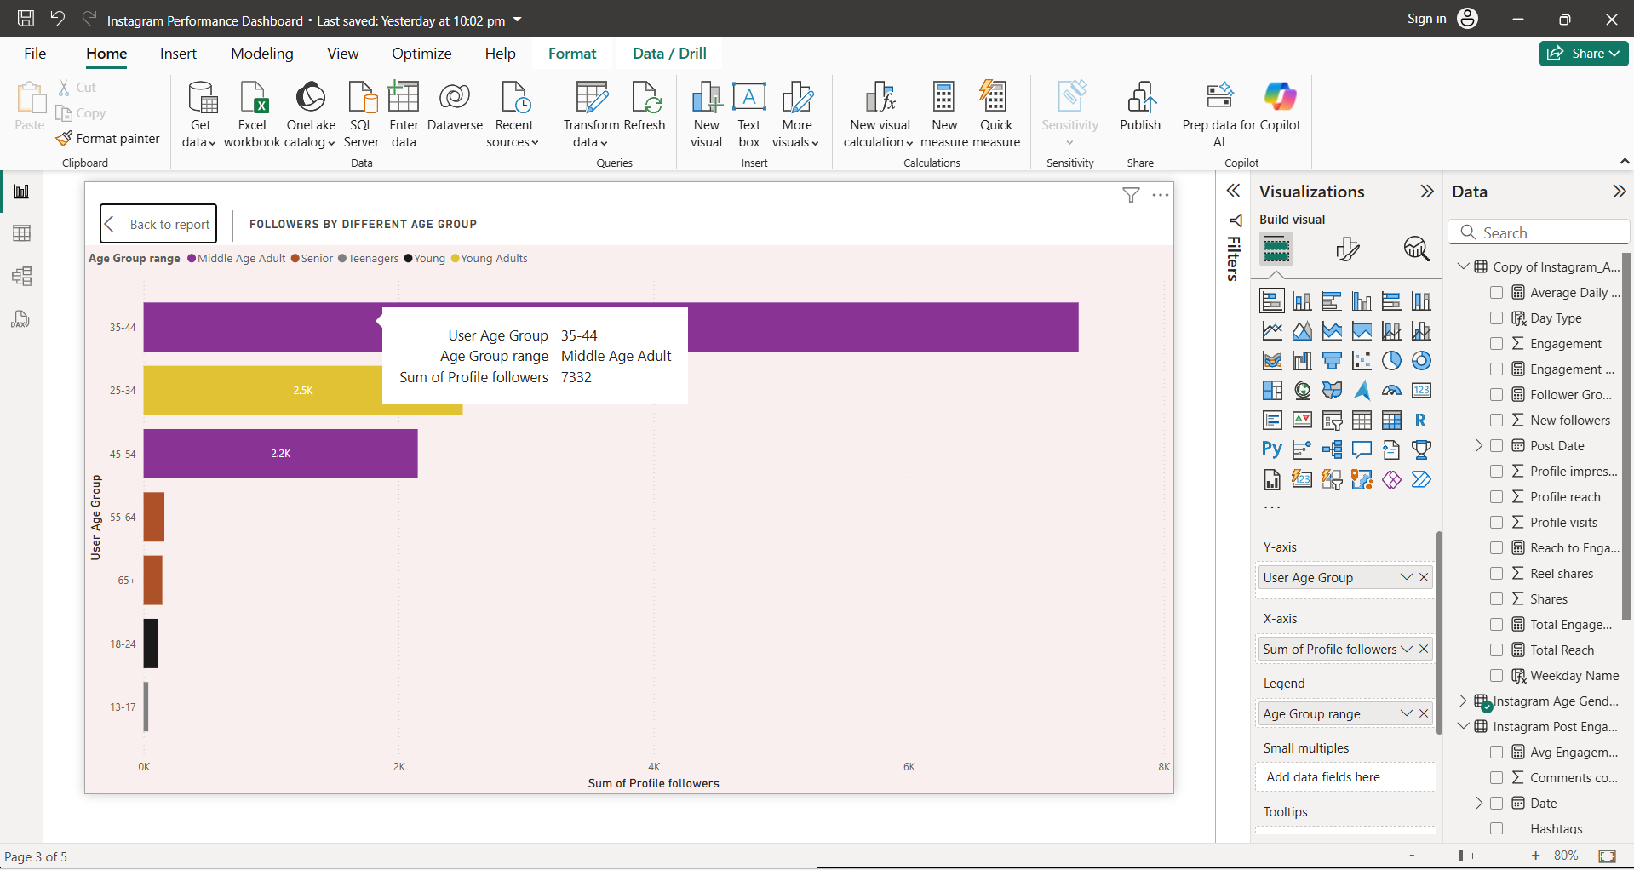

* **Followers by Gender**

Below Pie chart showcase the number of followers based on gender (i.e. Male, Female, Unknown). Majority followers are Female helps to understand how to tailor messages accordingly.

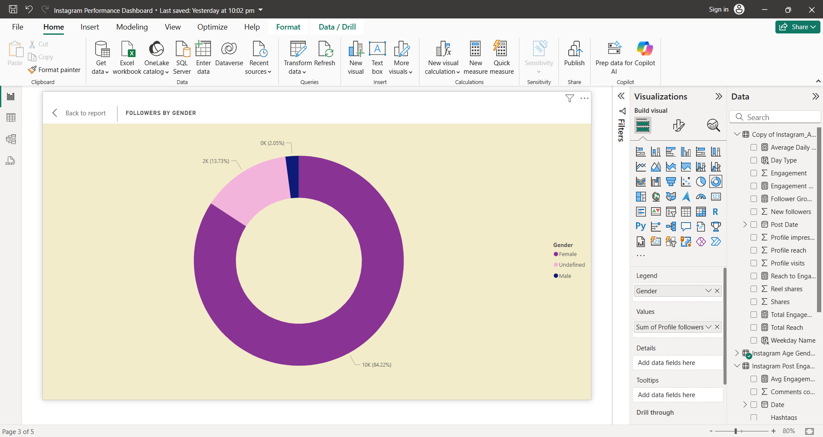

## Dashboard 4: Cities & Regions

This dashboard gives Geographic insights to support localized campaigns.

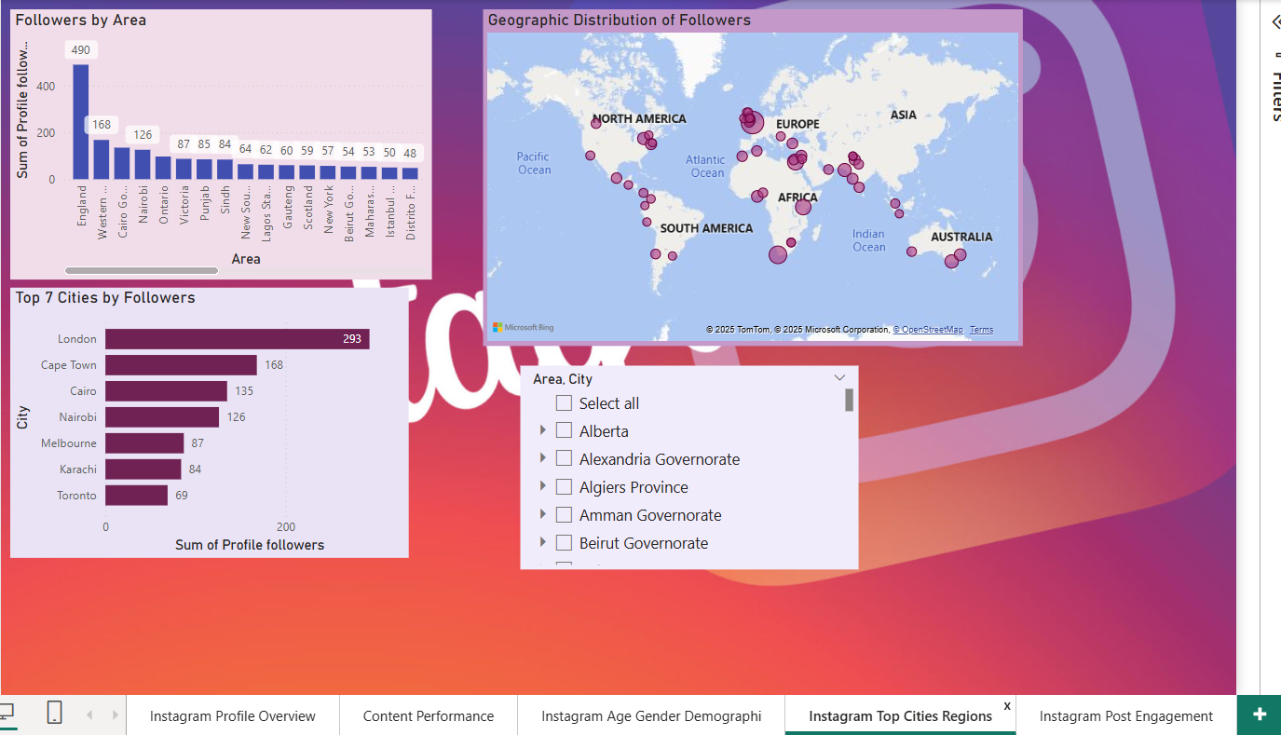

**Visualization and Insights**

* **Followers by Area**

It shows the number of followers by area in the descending order, where England comes first with 490 followers. Whereas, Pichincha placed at the last with just 25 followers. Shows which macro-regions have the highest audience share.

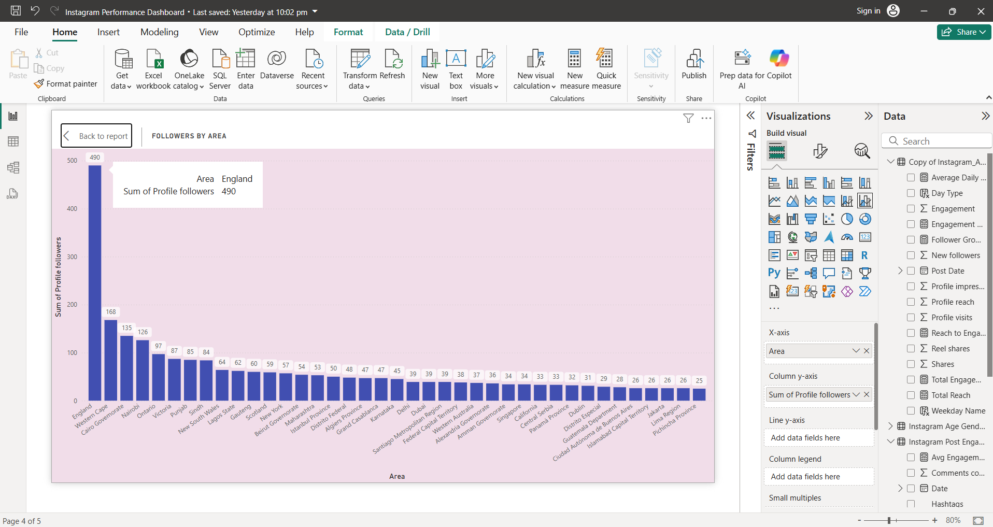

* **Top 7 Cities by Followers**

Top 7 cities with the highest numbers of followers, in which London comes first with 293 followers. These cities are the key cities to focus marketing or influencer collaboration.

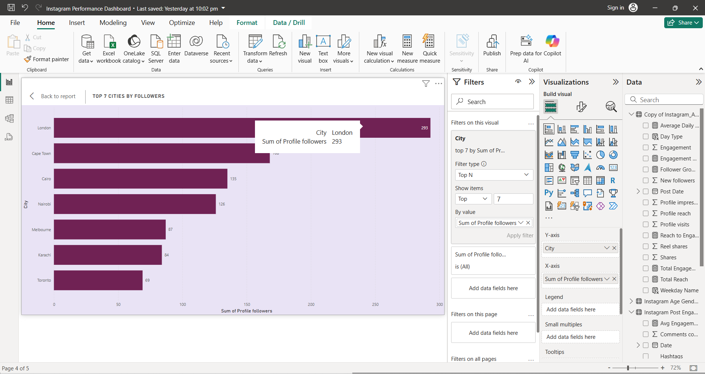

* **Followers by City**

This map shows the geographic distribution of followers across the world. Where, Circle showcase the cities with the followers also bigger the size of the circle higher the number of followers belongs to that city. And we can see that the greatest number of followers are from United Kingdom.

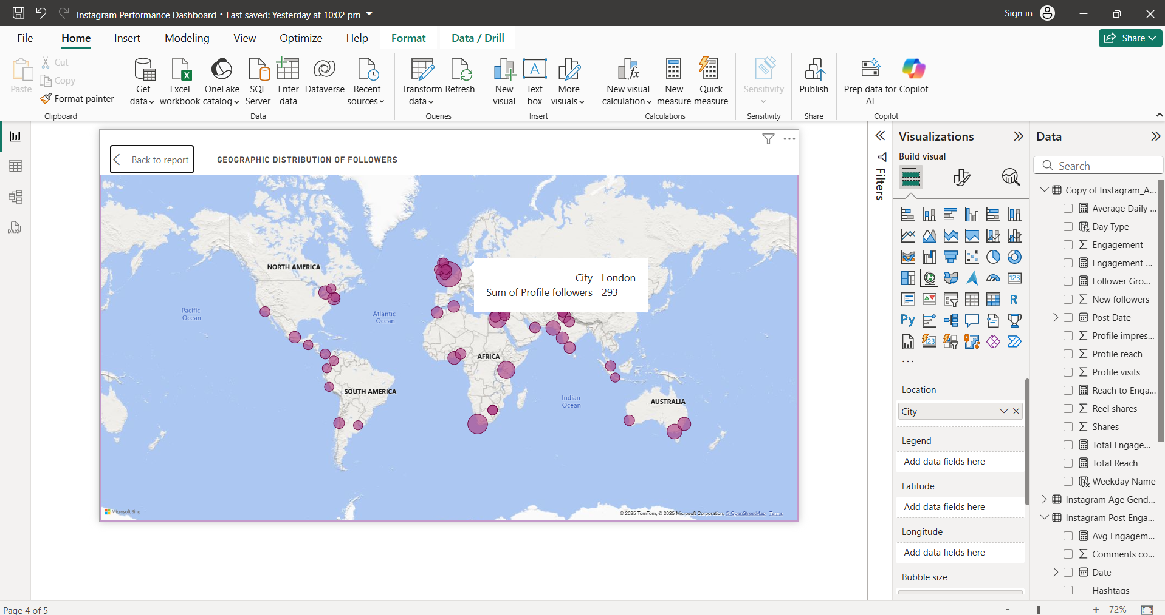

* **Slicers: Area & City**

Enables interactive drilldown into city/region insights.

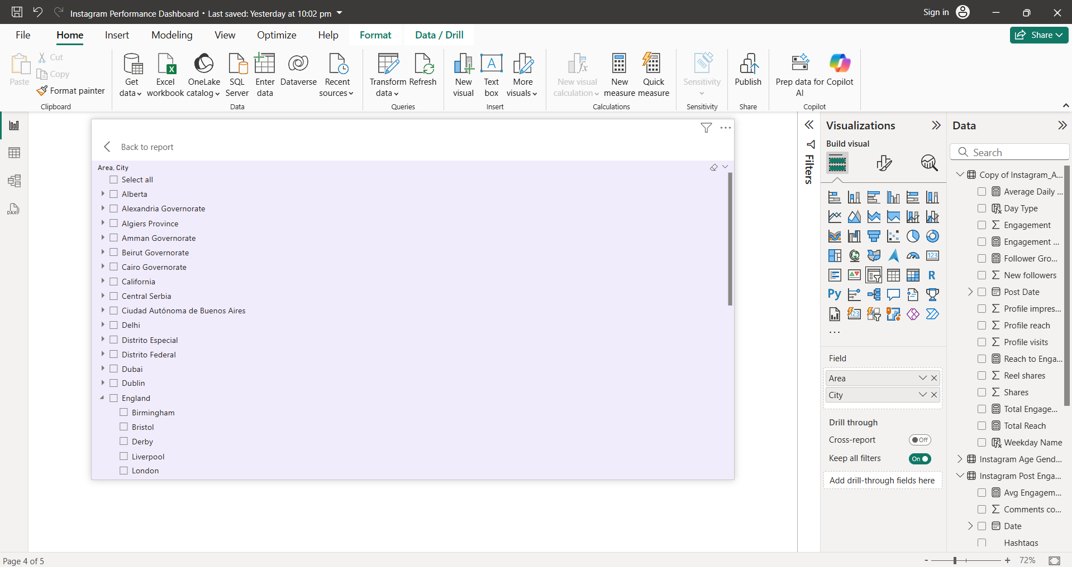

## **Dashboard 5: Post Engagement Analysis**

This dashboard helps to understand post level performance.

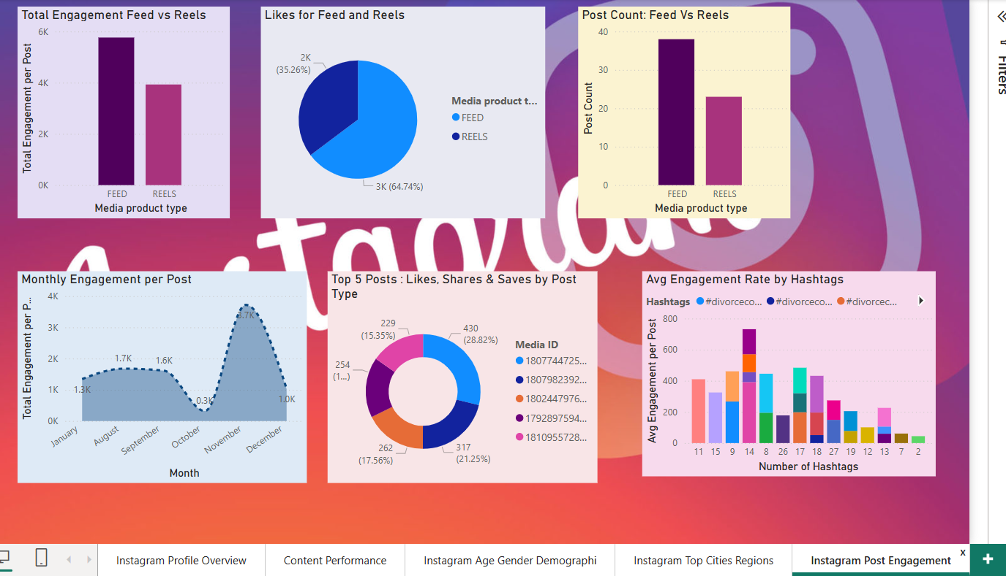

**Key Measures** :

* Total Engagement per Post = SUM('Instagram Post Engagement'[Like count]) + SUM('Instagram Post Engagement'[Comments count]) + SUM('Instagram Post Engagement'[Shares]) + SUM('Instagram Post Engagement'[Unique saves])
* Post Count = DISTINCTCOUNT('Instagram Post Engagement'[Media ID])
* Avg Engagement per Post = AVERAGEX(VALUES('Instagram Post Engagement'[Media ID]), [Total Engagement per Post])

Also,

Extracted Hashtags: Text.Combine( List.Select( Text.Split([Media caption], " "), each Text.StartsWith(_, "#") ), " " )

Number of Hashtags per post : List.Count(List.Select(Text.Split([Caption for Hashtags], " "), each Text.StartsWith(_, "#")))

**Visualization and Insights**

* **Engagement by Feed vs Reel**

This column chart shows the total engagement for feed post and reels, where feeds have more engagement than reels.

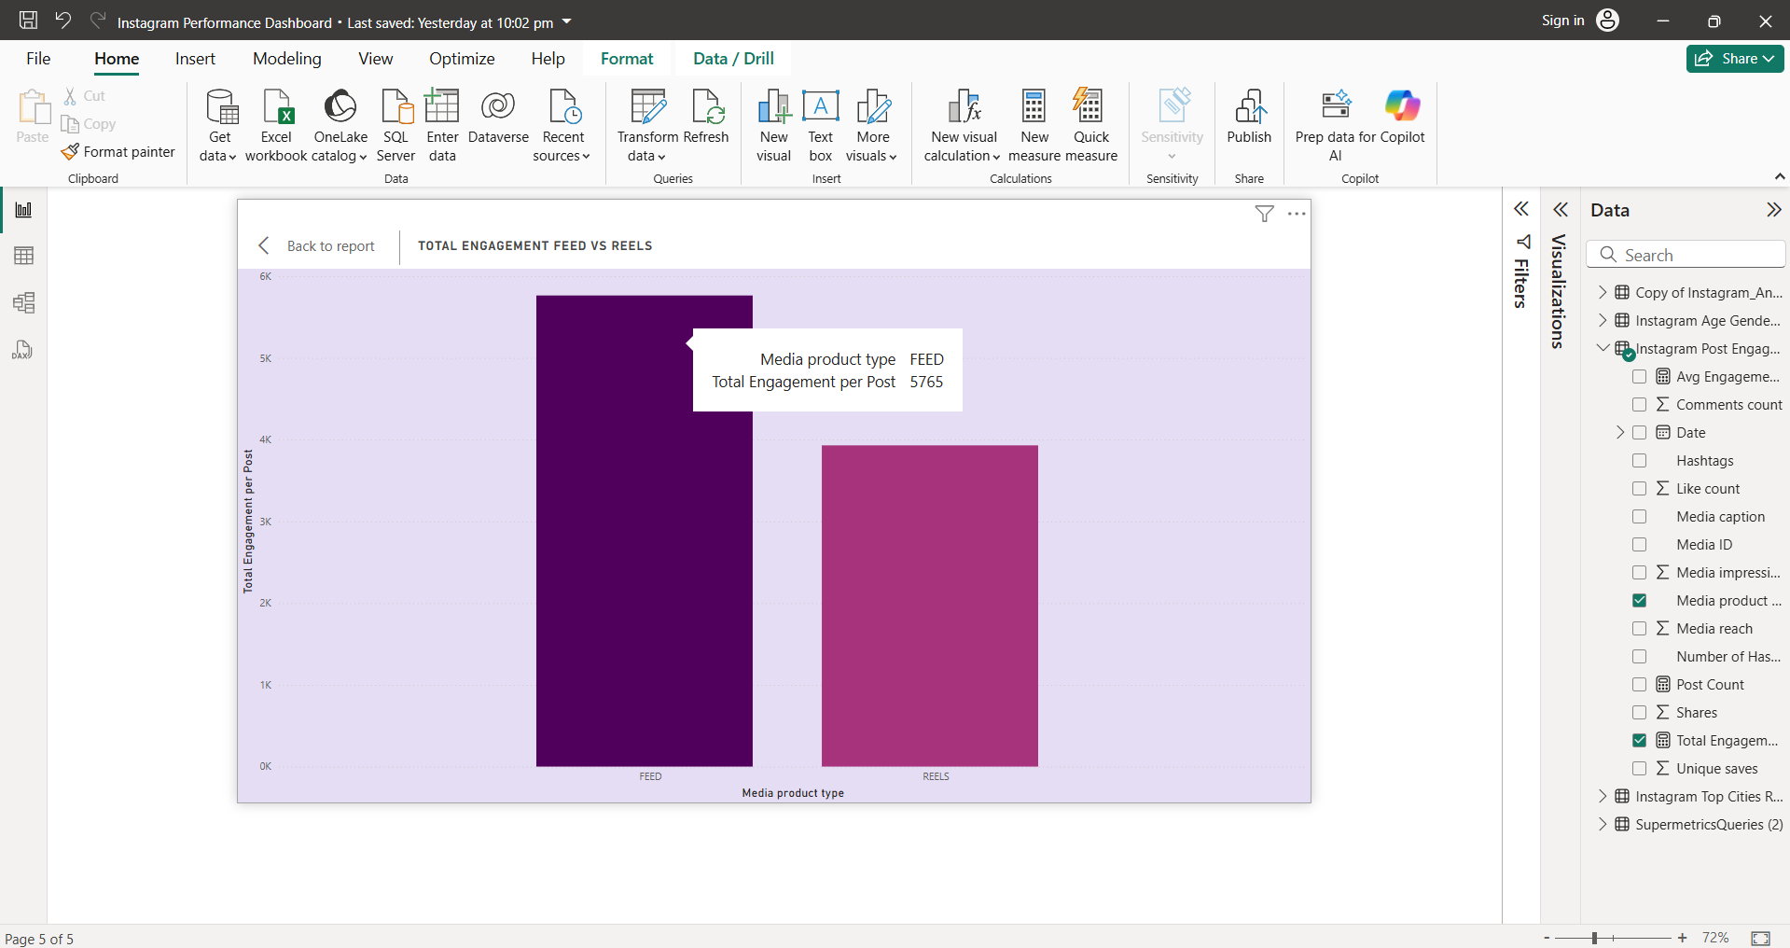

* **Monthly Total Engagement per Post**

Next is a Line chart indicates monthly engagement per post, this helps to track changes in per-post performance over time. Where Nov has the peak engagement number and graph going down in October.

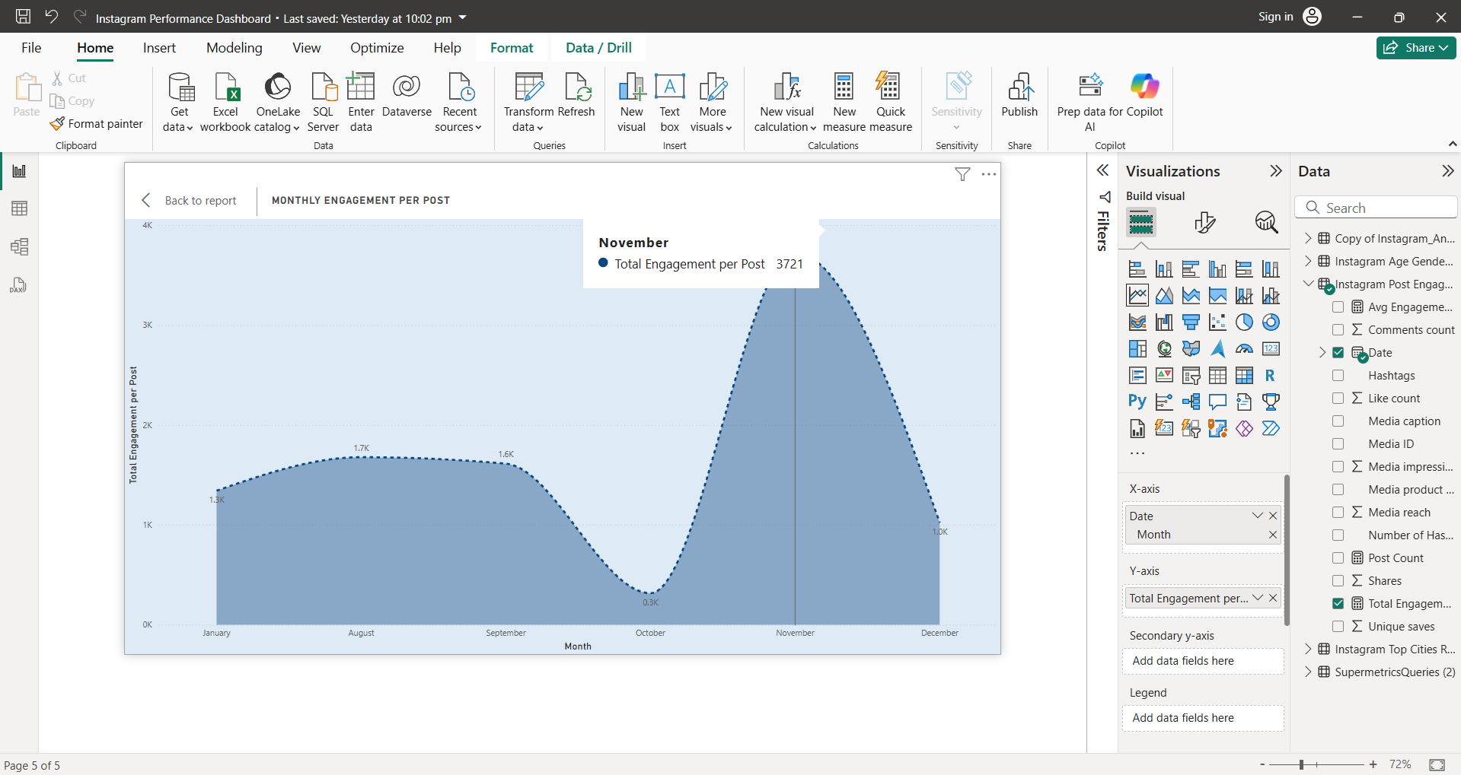

* **Likes for Reels vs Posts**

Below pie chart showcase the total likes for feed and reels, It is very easy to understand that feed gained more likes that reels. Feed has almost double number of likes that reels.

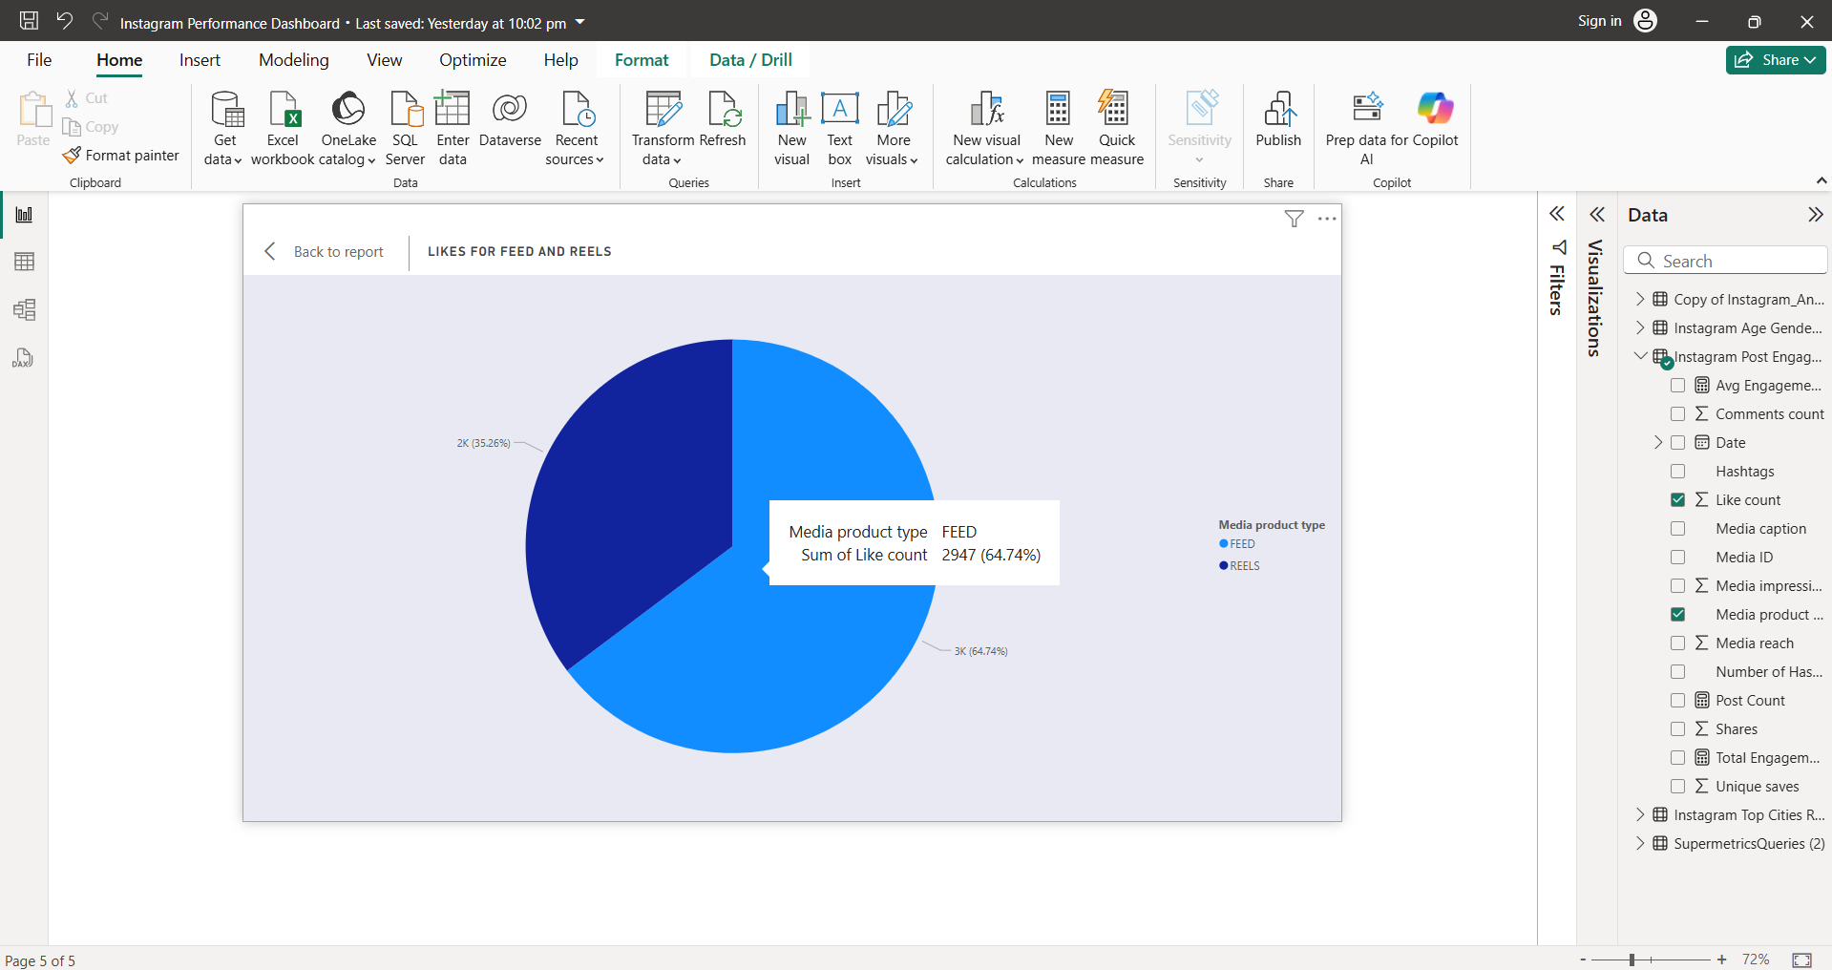

* **Top 5 Most Liked Posts**

This Donut chart indicates the top 5 most liked posts and it also shows type of the post, number of likes, shares and unique saves. Most liked post is of type Feed and has 430 likes. It quickly shows top performing content.

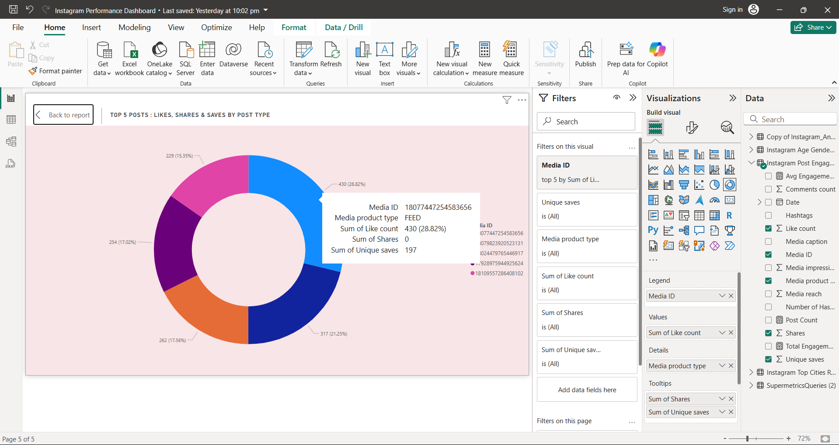

* **Average Engagement Rate by Hashtags**

Hashtags helps to gain engagement, here we have check the avg engagement rate by hashtags where number of hashtags, hashtag(extracted), avg engagement rate is visible.

Mostly used hashtags: #divorcecommunity #singlemum #singlemumuk etc.

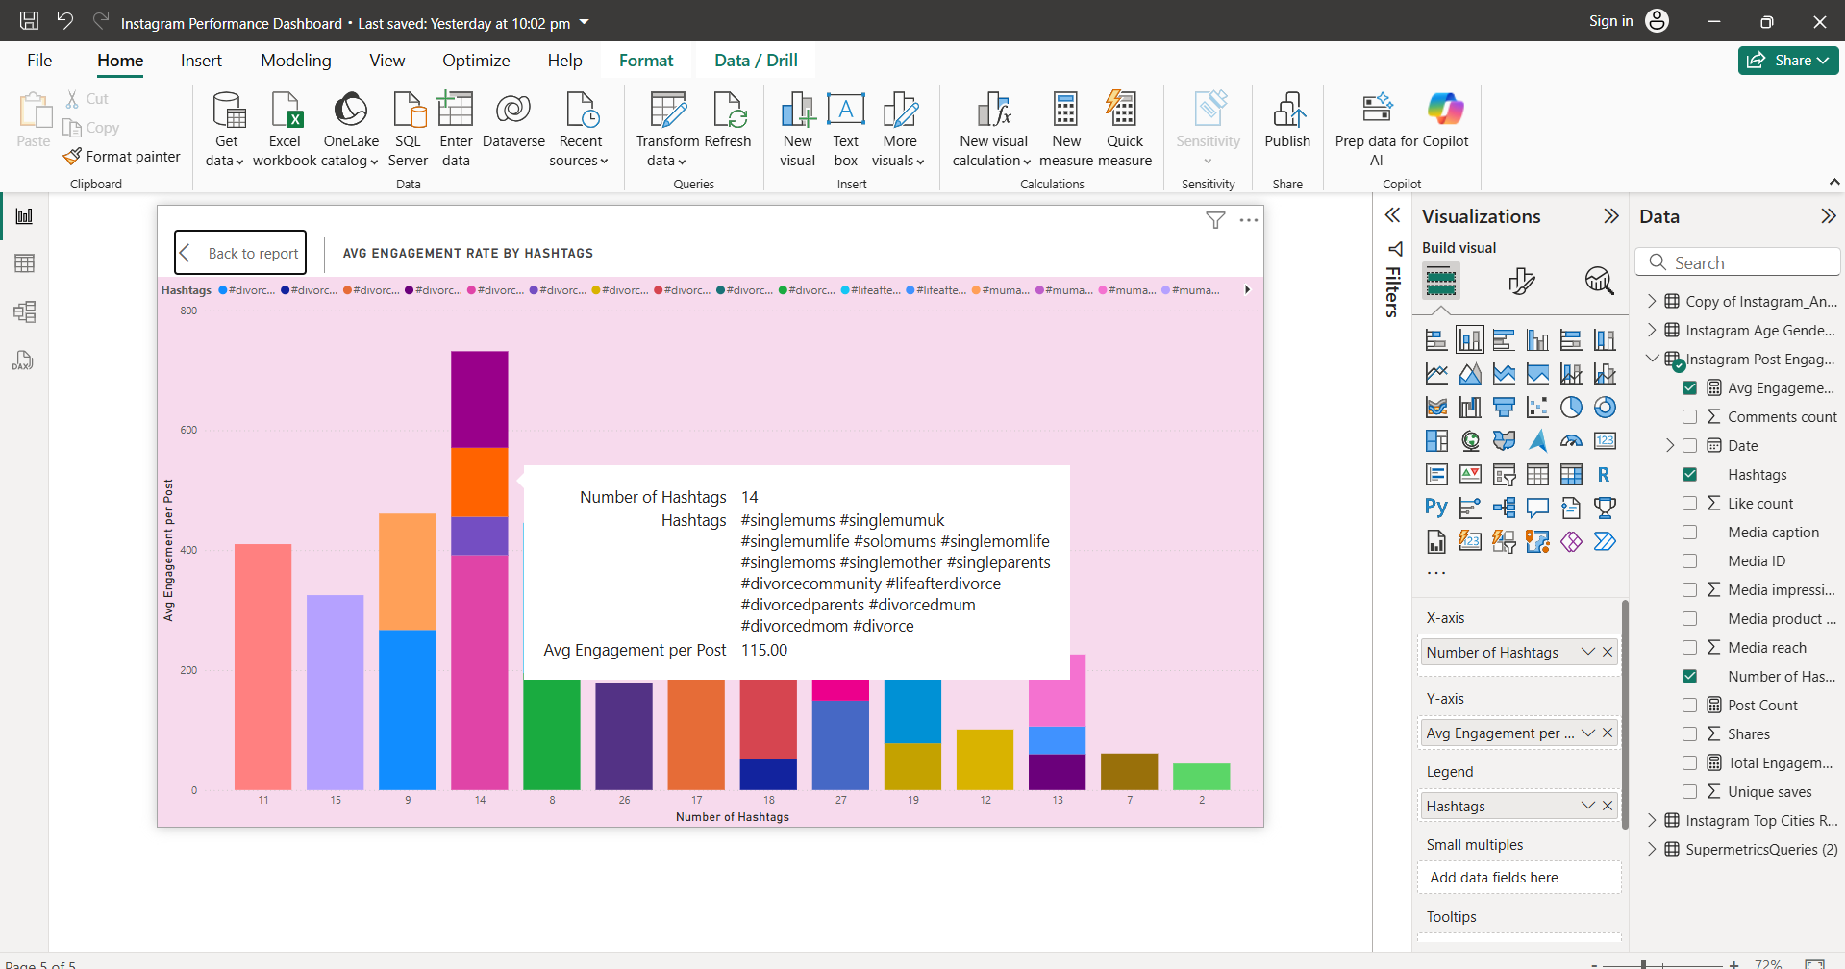

# Questions to Consider

1. What are some key metrics you would track to measure the performance of

Facebook and Instagram posts?

: To evaluate post performance on both Facebook and Instagram, the following key metrics should be tracked:

* Engagement Rate: Engagement/ Reach shows relevancy of your content
* Total Engagement: Like + Comments+ Shares + saves.
* Total Reach: Sum of profile reach (Total no. of unique users who saw the post)
* Follower Growth: New followers gained
* Post Type: Helps to identity which type of content is performing the best
* Performance by Weekdays or Weekend

2. How would you determine if an Instagram Reel is performing well?

: To identify that we can consider below points

* Reel Shares: Informs how many users found it valuable to share.
* Engagement rate: Engagement/ Reach
* Reach: How many new users saw the reel
* New followers’ growth: If it is helping to grow the audience

3. How would you A/B test different ad creatives on Facebook?

:

* You can create two versions of your content, varying only one element.
* Divide target audience equally between both versions
* Upload both posts at the same time
* Monitor engagement, reach, CTR, CPR etc
* Analyse which version of post performed better
* Use that insight to improve future campaigns

4. What insights can you gain from the provided dataset?

Key Insights:

* Time-Based Insights:
* April-2024 recorded the highest engagement, making most engaging month
* 14 April 2024 was the most engaging day with over 15000 engagements.
* Feb 2025 saw a spike in follower growth with 144 new followers.
* April saw highest profile visits.
* Day of week performance:
  + Weekends show higher engagement best time for posting
  + Sunday is the most engaging day.
* Audience Demographics:
  + The Large number of followers belongs to 25-44 age with 7.5k followers, content can be adult-focused.
  + Age group 13-17(Teenagers) showing less interest.
  + Female makes majority of the follower base, this insight helps refine tone, messaging and visual style of post.
* Geographic Distribution
  + London leads as the top city with 293 followers, it shows a strong follower base from urban areas which will help to design regional content strategies.
* Content Type:
  + Feed posts are working better than reels as it has nearly twice the number of likes compared to reels.
  + Also, Hashtag help to boost the engagement.

5. What additional analyses would you recommend?

: Here are my few humble suggestions,

* Localized Campaign opportunities: design regional content strategies based on the city data
* Hashtag Effectiveness: Compare engagement rate by hashtags
* Weekend Posting: Post on the weekends to improve engagement rate
* Use of Sentiment Analysis: Can use NLP to understand emotions in the comments whether positive or negative comments are coming.
* Group similar themed posts and analyse average engagement metrics
* Focus on making content for adult age group.